COS20019 - Cloud Computing Architecture  
 Assignment 1 – Part B  
  
Name : Pham Do Tien Phong  
Student ID :104189767  
  
**1.Infrastructure deployment**1.1 – VPC  
I create my VPC (PPhamVPC)  
4 subnets ( 2 public subnets and 2 private subnets )  
  
2 public subnets associate with routable (PublicRouteTable) to Internet Gateways (PhongPha InternetGateWay)  
This is my Resource map   
I create 3 security groups (3 security groups I selected are 3 SG I used for this assignment )  
1.3 – EC2 virtual machine  
 . 1.3.1 – Bastion/Web server instance   
  
I create a Web server instance as well add an elastic IP address for it to ensure my Web-Server URL remains persistent.   
. 1.3.2 – Test Instance  
I can SSH into an instance in a private subnet ( private subnet 2 )  
I ping successfully.  
  
1.4 – RDS database instance   
This is my database   
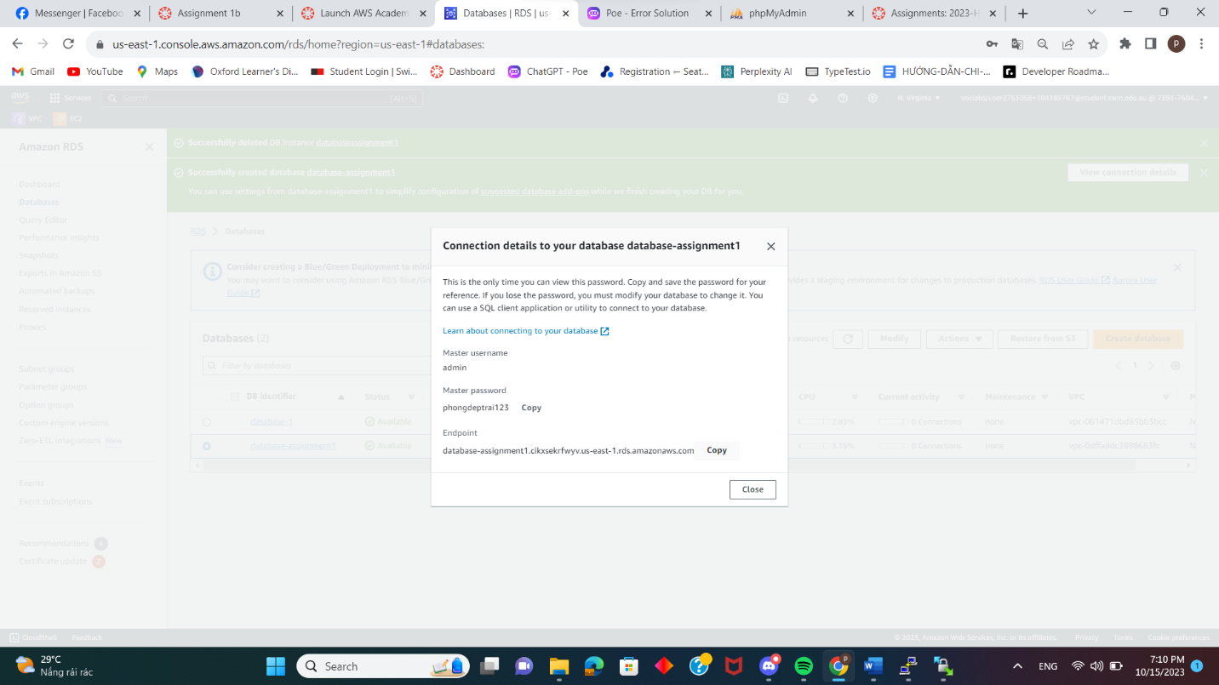  
The details of my database.  
  
This is the display of phpMyadmin . The username : admin and the password : phongdeptrai123.  
  
This is mySQL command.  
This is my WinSCP where I store the photos.  
1.5 – Network ACL  
  
This is my network ACL with the requirements : Inbound Rules and Outbound Rules  
  
**1.Functional requirements of Photo Album website**2.1 Photo storage   
This is my S3 bucket where stores my photo.   
<https://photoweb.s3.amazonaws.com/PhongParent.jpg>  
  
<https://photoweb.s3.amazonaws.com/TienPhong1.jpg>  
  
<https://photoweb.s3.amazonaws.com/TienPhong2.jpg>  
  
These pictures are the photos in the S3 bucket and links are accessed to it.

2.2 Photo meta-data in RDS database   
  
I create a table to store the photo in phpmyadmin.   
  
2.3 Photo Album website functionality   
First of all, I modify the costant.php . The things I change are student name ; student id ; tutorial session; bucket name ; db name ; action required of endpoint, username, password ; db photo creationdate ; db photo s3 reference, respectively.   
And finally, this is my serever.  
This is my URL of the album.php page  
<http://ec2-54-92-231-101.compute-1.amazonaws.com/cos20019/photoalbum/album.php>